Name:________________________________________ Date:____________
Introduction to Microscopy Lab Activity
Today we will be covering the basics of microscopy. For both the lab practical section of the AICE Biology exam as well as this class in general, you will be expected to be able to use a compound light microscope for examining, identifying, and describing specimens. In today’s lab activity, you will practice two basic microscope techniques: locating and focusing on specimens, and preparing a wet mount. You will also practice microscopic drawings in both of these sections.
Exercise A: Labeling the parts of a Compound Microscope
Label the parts of the diagram below using class notes. Indicate the part’s name as well as function for indicated microscope parts.
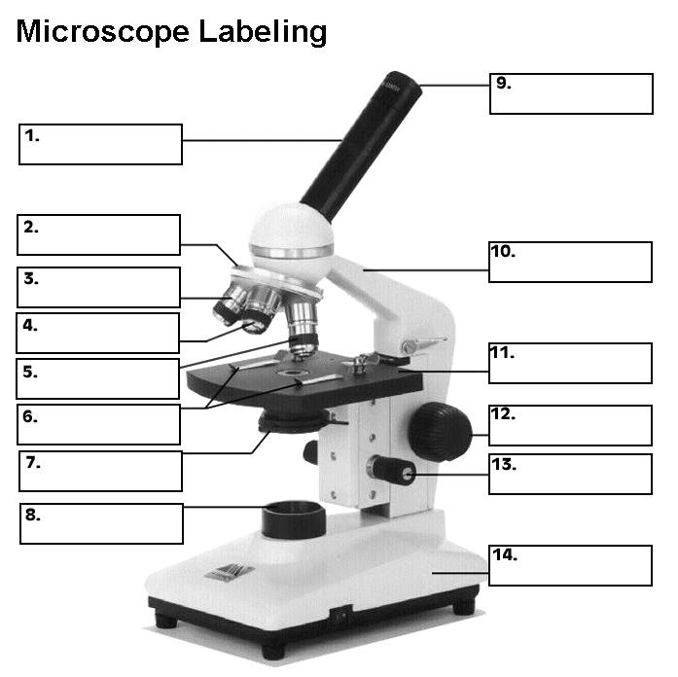
Function/significance of #3-5:_____________________________________________________
______________________________________________________________________________
Function/significance of #7:_______________________________________________________
Function/Significance of # 9:______________________________________________________
Differences between/purpose of #12 and #13:_________________________________________
______________________________________________________________________________
Exercise B: Magnification
Your microscope has 3 magnifications: Scanning, Low and High. Each objective lens has a labeled magnification. In addition to this, the ocular lens (eyepiece) has a magnification. The total magnification is the ocular x objective. Fill in the chart below to calculate the potential magnifications of your microscope.
 | Magnification | Ocular lens | Total Magnification
Scanning
Low Power
High Power
Exercise C: Focusing on a specimen and illustrating what you see.
1. When focusing on a specimen on your slide, always start with the scanning objective. Most likely, you will be able to see something on this setting. Use the Coarse Knob to focus. The image may be small at this magnification, but you won't be able to find it on the higher powers without this first step. Do not use the stage clips, begin by moving the slide around until you find something. Once your image is mostly focused using the course knob, switch to the fine knob to focus more sharply. If the specimen is too light or too dark, try adjusting the diaphragm. Notice that you can see more detail at lower light settings. If you allow too much light into the diaphragm, the specimen becomes washed out. If you see a line in your viewing field, try twisting the eyepiece, the line should move. This line is a pointer, and is useful for pointing out things to your lab partner or teacher.
Specimen on slide:_______________________________________
Magnification of specimen:________________________________
Describe in words what you see:___________________________________________________
____________________________________________________________________________________
____________________________________________________________________________________
You are now going to illustrate what you see at the scanning objective level.
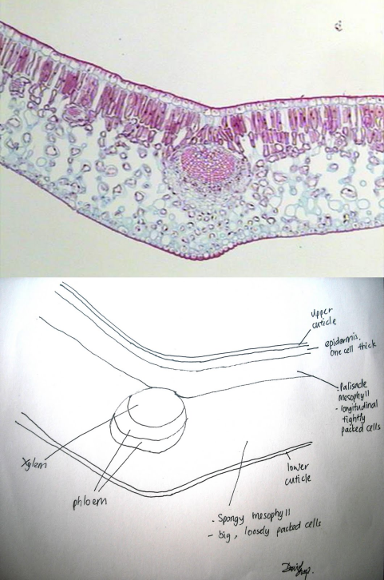
Advice on drawing from the microscope:
A low magnification is often called a plan diagram as it shows the distribution of tissues in a section and shows the proportions of the different tissues. Although these diagrams are at low power, you can use the higher power to identify different tissues and make sure you are drawing tissue boundaries in the right places. You do not draw any individual cells in a lower power plan diagram.
Tips for drawing at scanning or low power:
• make the drawing fill most of the space provided;
leave space around the drawing for labels and annotations
(if required by the question)
• use a sharp HB pencil (never use a pen)
• use thin, single, unbroken lines (often called ‘clear and
continuous lines’)
• show the outlines of the tissues
• make the proportions of tissues in the diagram the same as
in the section
• do not include drawings of cells
• do not use any shading or colouring
• label the diagram only if you are asked to do so
• write all labels and drawings in pencil only. Do NOT write
over your labels in ink.
Plan Diagram of your specimen:

2. Once you've focused on Scanning, switch to Low Power. Use the Coarse Knob to refocus at this higher magnification. Again, if you haven't focused on this level, you will not be able to move to the next level.
Plan drawing of your specimen on low power:

3. Now switch to High Power. (If you ever have a thick slide, or a slide without a cover, do NOT use the high power objective). At this point, ONLY use the Fine Adjustment Knob to focus specimens. Your course knob should remain where you focused it to on low power. High power drawings should be drawn to a reasonable size so you can see any details inside them.
Tips for drawing at high power:
• make the drawing fill most of the space provided; leave space around the drawing for labels and annotations (if required by the question)
• use a sharp HB pencil (never use a pen)
• use clear, continuous lines (see above)
• draw only what is asked in the question, e.g. three cell types or one named cell and all cells adjoining it
• show the outlines of the cells
• the proportions of cells in the drawing must be the same as in the section you are drawing
• plant cell walls should be shown as double lines with a middle lamella between the cells; the proportions of cell walls should be drawn carefully.
• show any details of the contents of cells – draw what you see not what you know should be present
• do not use any shading or colouring
High power drawing of your specimen:

Exercise D: Making a Wet Mount
1. Gather a thin slice or piece of specimen. This can usually be done with forceps, but occasionally a scalpel is necessary. If your specimen is too thick, then the coverslip will wobble on top of the sample like a see-saw, and you will not be able to view it under High Power.
2. Place ONE drop of water directly over the specimen. If you put too much water on your slide, the coverslip will float on top of the water, making it hard to draw the specimen. Too much water is messy and causes the specimen to move around and potentially float away.
3. Place the coverslip at a 45 degree angle (approximately) with one edge touching the water drop and then gently let go. When performed correctly, the coverslip will perfectly fall over the specimen.
4. Follow the instructions listed above to first scan your specimen, then focus in at a low power magnification. Complete drawings for both of these magnifications.

Low power drawing of your specimen:

High power drawing of your specimen:

