Name:
Period:
Prokaryotic Gene Regulation
PhET Simulation of Operon Function

The purpose of this activity is to develop an understanding for how prokaryotes control gene expression. In 1961, Francois Jacob and Jacques Monod proposed the operon model of gene regulation in bacteria. The model was based on their study of the genes in E. coli that code for enzymes that affect the breakdown of lactose.
Because of the pioneering work of Jacob and Monod, the lac operon is typically used to illustrate gene regulation in bacteria. Gene regulation in eukaryotes is quite different.

Click Here to get to the Gene Machine: The Lac Operon simulation. You will need to download and run the Java program and this will require you to be patient. Once the Java window is open you should see an image like the one below. Now you are ready to begin the simulation.

Please type directly into this form. When you are done, follow the Turnitin instructions on the board to submit this assignment. Please answer all questions in complete sentences.

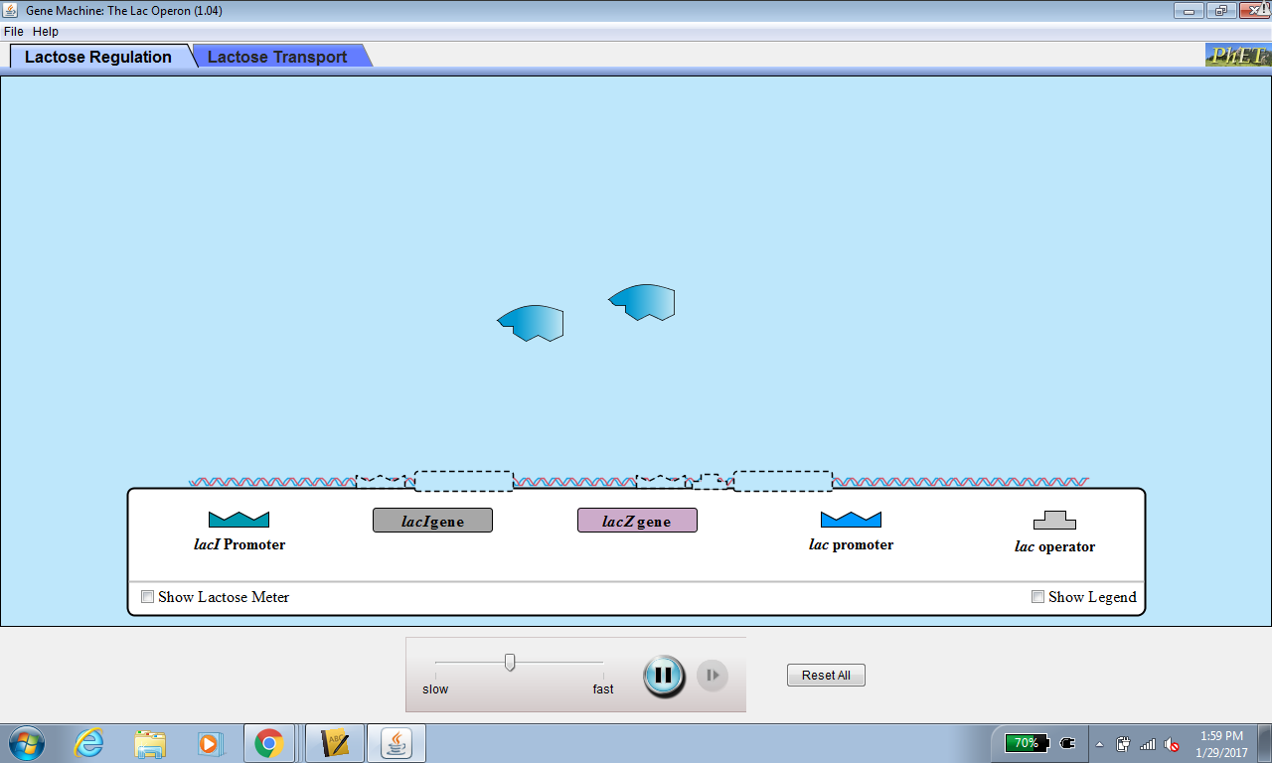

- Drag the lac promoter to the appropriate location on the stretch of DNA. Wait a few seconds, then describe in complete sentences what happens.
- Now drag the lacZ gene to the appropriate location on the stretch of DNA. Wait a few seconds, then describe what happens.
- In the upper left-hand corner, there is a tool that allows you to inject lactose into the environment. Click on the red button to manually inject 20-25 lactose molecules. Wait a few seconds, then describe what happens.
- Note that the lacZ gene continues to be transcribed and translated even in the absence of lactose. Why is this a problem for the E.coli cell?
- Drag the lac operator to the appropriate location on the stretch of DNA. Wait a few seconds, then describe what happens.
- Now drag the lacI promoter AND lacI gene to the appropriate location on the stretch of DNA. Wait a few seconds, then describe what happens.
- Again, add some lactose to the environment. Describe the result of adding lactose.
- What happens when the lactose is removed from the environment?
- Click on the Lactose Transport tab at the top of the screen. Drag all of the operon elements to their appropriate locations on the stretch of DNA. Wait several seconds until the manual lactose pump appears. Add 20-25 lactose molecules. Describe the role of the lacZ gene and the lacYgene.
- Why do you think these genes located next to one another and controlled by the same operator/promoter?

Conclusion questions:
Flip to page 390 in a textbook to answer the following:
1. Describe the components of the lac operon, including lacZ, lacY, and lacA. What does each component code for?

2. Differentiate between inducible and repressible enzymes.

3. What is the functional or evolutionary benefit of th lac operon? What would the presence of these genes enable for bacteria?

4. We will be continuing to talk about eukaryotic gene control as we get into genetics more deeply. Google search one eukaryotic protein you are interested in (if you don’t know where to start, google a body or cellular process that interests you and select one of the important enzymes). How is this protein controlled genetically? Include a description of the gene, where it is located in the organism’s genome, what it codes for, and how expression occurs.

