**Karst Landscapes: Readings and a Simulation Lab**

**What Exactly is Karst?**  
Karst is a landscape formed from the dissolution of soluble rocks including limestone, dolomite and gypsum. It is characterized by sinkholes, caves, and underground drainage systems (Fig. 1). Nearly all surface karst features are formed by internal drainage, subsidence, and collapse triggered by the development of underlying caves (Palmer, 1991). Rainwater becomes acidic as it comes in contact with carbon dioxide in the atmosphere and the soil. As it drains into fractures in the rock, the water begins to dissolve away the rock creating a network of passages. Over time, water flowing through the network continues to erode and enlarge the passages; this allows the plumbing system to transport increasingly larger amounts of water (Gunn, 2004). This process of dissolution leads to the development of the caves, sinkholes, springs, and sinking streams typical of a karst landscape.

|  |
| --- |
| [Fig. 1: The features of a karst system.](http://www.esi.utexas.edu/outreach/caves/images.php?img=ktfig1)  Fig. 1: The features of a karst system. |

**Why is Karst Important?**  
Dissolution associated with karst development in central Texas limestone has created a complex underground water flow network that includes caves large enough for humans to access. Rainwater travels through the network, controlled by the Balcones fault system, until it reaches the water table (Ferrill et al., 2004). The karstified limestone acts as an aquifer where water can be stored and later extracted by humans.

Two million people in central Texas get their drinking water from the karst aquifer known as the Edwards Aquifer (Sharp and Banner, 1997). This resource is especially important for central Texas as the region becomes more urbanized. With a higher density of people, central Texas will face higher demand and increased pollution. Just like rainwater, pollutants can easily pass through the karstified limestone. Another difficulty is that streams and surface runoff entering the aquifer via sinkholes and caves bypass the natural filtration produced by seeping through soil and bedrock. This direct recharge quickly replenishes the water supply; however, it also leaves the aquifer particularly vulnerable to contamination (Drew and Hötzl, 1999).

Source: University of Texas

**Limestone Caves in Florida, A Case Study: The Santa Fe Bat Cave**

**KARST PROCESSES**   
Affecting some 15% of the land, karst processes and the resulting karst features, including caves and sinkholes, involve the dissolution of soluble rocks, such as gypsum, limestone, dolomite, rock salt, etc. In carbonate rocks (limestones and dolomites mainly), the solution process is due to the chemical action of acidic water that dissolves away the rock.  This creates a series of holes which increase in size over time. Extensive solution causes caves and caverns as well as sinkholes and other karst (=solution) features.

**How and why solution happens:**

**1. You have to have soluble materials**   
This part of the state is underlain by very thick limestone (calcium carbonate) and dolomite (calcium and magnesium carbonate) layers, that have been subjected to all sorts of processes since they were deposited. Some processes have been structural and created joints (cracks) and faults (cracks where the layers have moved) in the limestone. Many have been chemical in nature.

2**. You have to have water**   
The water that does all this geological reshaping comes from rainfall (or any precipitation for that matter..). The Gainesville area has plenty of water. Every year on average some 54 inches of rain fall on the area. But having enough water is not enough to bring about solution. By itself, pure water would not especially affect limestones. That's because pure water is neutral, neither acidic nor basic.    
**Where does the water in and around Bat Cave come from?**   
All water ultimately derives from the earth's oceans. Florida is no exception. This constant exchange between oceans, land and life is often depicted as the hydrologic cycle, a great cycle that distributes water and heat across the surface of the Earth.   
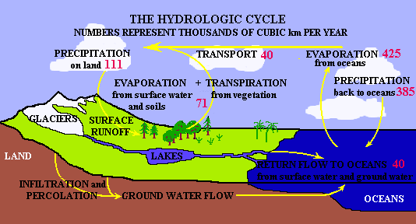

The hydrologic cycle in the Bat cave area is considerably simpler and, like any area, can be quantified in a water budget equation. The area receives water from **precipitation** and **inflow from surrounding areas**. It loses water through **evaporation and transpiration** and from **outflow to other areas**. Some of the water may be **stored in lakes or ground water**, and this stored amount may increase or decrease during wet or dry years. Some water is also used by us 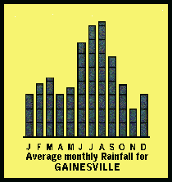(**consumptive use**) and is not returned to the local system..

**Rainfall**   
Annually, Alachua County receives some 54 inches of rainfall. June-September are the wettest months. The least rainfall occurs in November. Most of the winter rainfall is associated with cold fronts. In the summers months rainfall is associated with convective thunderstorms and tropical storms and hurricanes. Rainfall pH in the area is between 4.6 and 4.7.

**Evapotranspiration (Water pulled by both evaporation and plants)**   
Evapotranspiration is around 34.5 inches/year, leaving a surplus of nearly 20 inches. There are no lakes and streams (surface waters) in the area because all the sediments and rocks in the area are highly porous and permeable. Therefore, all the water that does not evapotranspire actually infiltrates into the underlying Floridan Aquifer, which is the main aquifer (ground water reservoir) and source of water in Florida.

**Storage**   
This area is an area of high recharge to the Floridan Aquifer. The main rock unit of this aquifer in the area is the Ocala Limestone, and the underlying Avon Park Limestone. In this area, the Ocala Limestone is very close to the surface. There are but a few feet (<20') of sediments that overlie the limestone.  As you can see as you descend the staircase, in many places the limestone virtually outcrops at the surface.

**What happens to the water in and around Bat Cave?**   
The general land elevation at the site is around 80-90 feet. While the elevation of the potentiometric (water table) surface varies over time, being lower in drought times and of course higher during wet periods, it generally ranges between 35' and 40' MSL near the cave. In the aquifer, waterflow is both **diffuse**, where the water filters between the grains in the rock and **conduit flow** where water frows along enlarged openings in the limestone such as lineaments and  fractures. Water flow in this part of the county is actually towards the northwest, generally heading towards the Santa Fe River into which it discharges. No doubt as the area becomes more developed, increasing mounts are discharged through wells. Although some of this inflows again from irrigation, septic tanks etc, much is also evaporated.

The great importance of the Floridan Aquifer as a water resource (it is the main source of potable water in the area) and the fact that this is an area of constant inflow (recharge)  has led to increased concerns about the effect of human activities on the water supplies contained in the aquifer. For a long time, concerns mainly focused on industrial and urban activities.  In contrast, little concern was expressed about the effects of human activities in rural areas, because of the low population densities.  However, in the last three or four decades, we have come to realize that agriculture and other low density land uses can have as pronounced an effect on water quality as urban and industrialized areas.

**3. The water must be acidic**   
For water to be able to attack carbonates, it must be acidic. How does water become acidic?

***a) Atmospheric contamination***   
As water comes in contact with CO2 (carbon dioxide) in the atmosphere and in soils, water combines with carbon dioxide to make carbonic acid. Carbonic acid is a weak acid.  Given the small amount of carbon dioxide in the atmosphere(~0.03%),  we would expect rainwater to be mildly acidic (pH 5.5). But actually, the pH of rainwater  is 4.8. In other words, rainwater is more acidic than expected. That's because CO2 in the atmosphere is not the only gas that affects how acidic precipitation becomes. Air pollutants such as sulfur and nitrogen oxides (produced by human and natural activity such as volcanos) also combine with water to form sulfuric and nitric acids and therefore add to the acidity of rainfall, i.e. lower its pH. As we continue to increase the amount of pollution we produce, we can expect that precipitation will become more acidic, significantly increasing solution rates over those we would expect to occur "naturally".    
***b) Soil contamination***   
As water continues its journey and infiltrates the soils, it further reacts with soil CO2 and becomes even more acidic. Some of this soil CO2  comes from bacteria and other micro-organisms that metabolize organic materials. Also, if the soil is rich in organic materials and therefore carbon, this carbon will combine with oxygen from the atmosphere to produce CO2. Because of  bacterial activity and oxidation of carbon in soils, there can be 50 times more CO2 than in the soil than in the atmosphere.  In addition, there are dissolved organic acids in the soil (e.g. tannic acid) which also contribute to acidity.  The end result of all of these acid producing reactions is that the pH of waters in the soil or in the surficial aquifer may be as low as 3 and it is this acidic water that dissolves carbonates.

**4. This acidic water must be able to reach the carbonate rocks.**   
Areas where the water easily reaches the limestones either because the cover is thin, or permeable (such as sands) or where there are pathways that allow water to flow faster such as cracks in the rock layers (faults and joints)  are all places where solution takes place at a much greater rate. In places where the limestone is better protected by greater thicknesses of less permeable materials such as silts and clays solution happens at a much slower rate.    
    
**Where does this happen most?**

***1. Greater amounts of solution occur in areas of recharge.*** Recharge areas are areas where surface waters (rainwater and occasionally stream water) infiltrate and replenish ground water as they inflow to deeper aquifers.  As acidic water percolates downward in recharge areas it chemically attacks the limestone, most commonly near the top of the water table.  It is much less active in discharge areas (areas where water is lost from ground water (such as in springs for instance) because these waters have already reacted with the carbonates and have lost their acidity and are now neutral or slightly basic. Keep in mind that lots of factors (such as changes in sea level) can change the areal extent of recharge areas.

***2. Greater amounts of solution take place where the flow of acidic waters is concentrated***   
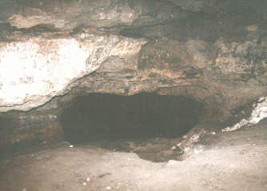In zones where water flow is greater such as along joints, fractures, faults and along bedding planes (surfaces), carbonates are in contact with greater quantities of acidic waters, and solution will concentrate its effects along these areas of greater flow .   
In this picture taken in the main room of Bat Cave, note how acidic ground water has concentrated its activity along bedding surfaces in the limestone creating what seems to be layers in the cave.

***3. Greater amounts of solution happen where fresh and salt water are mixing along the coasts***.  It turns out that if you mix fresh and seawater (between 4-45 % sea water), even though either the fresh and the salt water by themselves would not not lead to solution, the mix of the two will actually dissolve some of the limestone. This is going on today in coastal areas, and, because sea level has fallen and risen repeatedly in the past, such mixing  zones are much more prevalent in the state than just in present coastal areas.   
Average rates of solution vary tremendously, even locally, from virtually none to rates as high as 1cm/100yrs. While this may not seem much, remember the length of geologic time during which erosion operates.

 *** Caves can also form in lava flows (which of course is not an issue in Florida). But that method of cavity formation is totally different and not related to solutional karst processes.

**Source: Santa Fe College, Bat Cave Field Station Public Information**

**Cave Formations**

Cave formations are created when acid reacts with limestone or a rock containing 80% or more calcium carbonate. These formations are found on the walls, ceilings and floors of caves. Cave formations are called speleothems, from the Greek word "spelaion",cave and "thema" meaning deposit (Robertson, 2004). A number of conditions need to be present for speleothems to form within a karst enviornment. First the types of rocks within and surrounding the cave need to have an 80% content of calcium carbonate which is usually limestone, dolomite or a similar type of rock. The bedrock also needs to be highly fractured or jointed so the water can flow through or follow these joints or fractures. The bedrock also needs to be relatively close or at the surface. The fourth requirement for Karst and spelethem formation is a relatively moderate annual rainfall (>500 mm). The final requirement to form the speleothems is vegetation cover. Vegetation enhances the Karst process by producing more available acids. A few variable factors including humidity, temperature and air flow through the cave also play an important role in speleothem formation.

[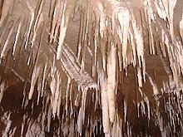](http://www.blackwaterrafting.co.nz/http:/www.blackwaterrafting.co.nz/) Caves and their features form when rainwater follows the cracks or joints in the rock material, usually limestone or dolomite. The rainwater combined with carbon dioxide forms a weak acid called carbonic acid. This weak acid once in contact with the limestone begins to dissolve the limestone. This process slowly creates larger and larger cracks and joints. The acid can remain at a consistent level, but often is strengthened due to increased amounts of carbon dioxide absorption from vegetation and soil surrounding the area. As more and more limestone is dissolved, large tunnels, networks of tunnels and joints, and actual caves begin to form. Once the caves and network of tunnels have formed, different types of cave formations begin to evolve. Many different speleothems are common in caves including stalactites (ceiling), stalagmites (floor), columns, rimstone pools, cave pearls, and baconstrips.

 Just one drop of water on the ceiling of a cave is all that is needed for a stalactite to start forming. Each drop contains a small amount of dissolved limestone that has been acquired from flowing through the cracks and joints of the bedrock. Once this drop is hanging suspended from the ceiling some of the contained carbon dioxide escapes the droplet. Due to this carbon dioxide escaping, the droplet can’t hold as much limestone so a thin external ring is formed. After the drop falls, a small layer is left as a residual. After multiple drops have fallen the dripstone forms a hollow stalactite. These stalactites are called soda straws. As growth continues the soda straw regularly becomes plugged by the deposition. The limestone rich droplets are now forced outside of the soda straw creating the droplets to leave a small “paper trail” of limestone. This results in the cone shaped dripstone. Average growth rates for dripstones (stalactites) are about ½ inch for every 100 years (Figure 2a and 2b). When multiple soda straws or dripstones join together a baconstrip is formed. These features usually form along a joint where multiple dripstones and stalactites can form.

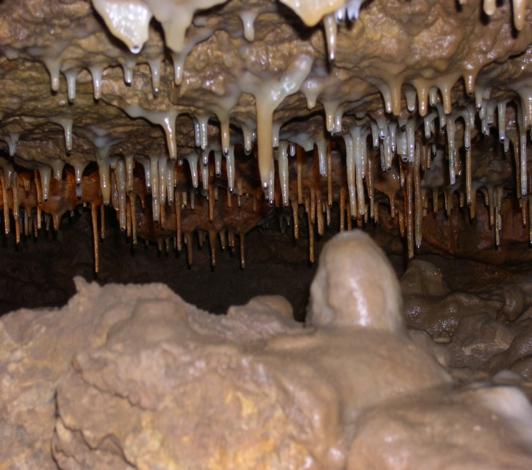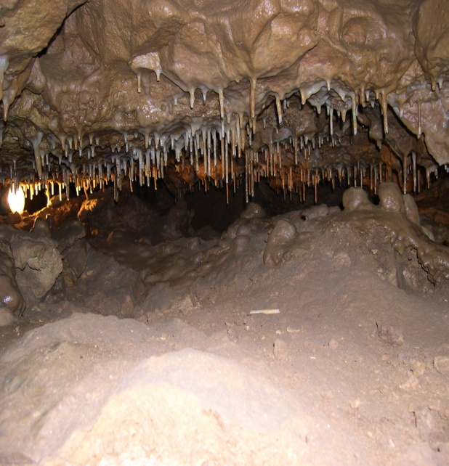

Both photos are examples of the many soda straws that are present at Crystal Cave which is located near Spring Valley, Wisconsin.

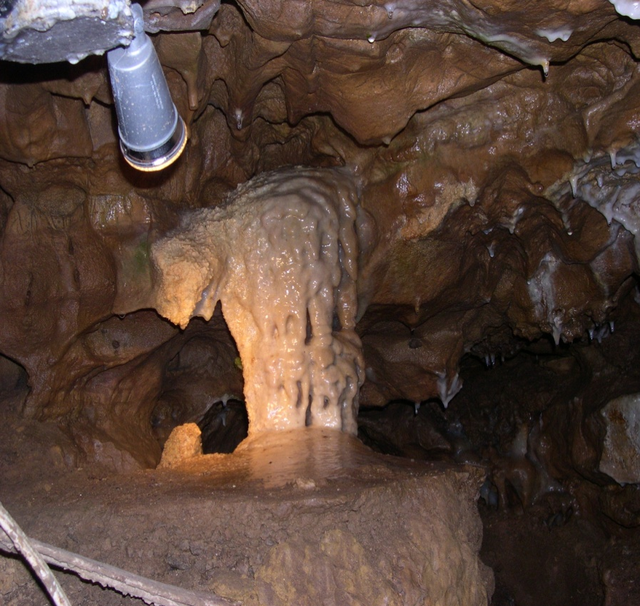   Stalagmites are formations that are created from the ground up. These formations form from the drops that have fallen from stalactites or dripstones. Even though the drops left some dissolved limestone with the stalactite (dripstone) some still remains in the droplet. As this droplet falls and hits the bottom of the cave or tunnel the droplet scatters. This process allows more carbon dioxide to be lost hence another dripstone formation on the cave floor has begun to form. After many drops have landed on the same spot a stalagmite has formed.

 Columns form after thousands if not millions of years of stalactite and stalagmite formation. When both of these two formations finally grow into one another a column is formed. This as stated earlier can take a very long time and in some cases never happens due to cave or environmental   
changes occurring.

Source: University of Wisconsin, Eu Claire. All images from Crystal Cave, Wisconsin

**Playing With Sugar: Exploring how water moves through a porous, soluble substance**

Now that you have read and learned about cave formations and the chemistry that creates different cave landmarks, you are ready to simulate a cave environment. *Include this in your lab notebook with the questions you answered.* **DO NOT EAT ANY SUGAR CUBES.**

Materials:

-25-30 sugar cubes  
-Clear plastic cup  
-Modeling clay  
-Toothpicks  
-Water  
-Food coloring  
-Water Dropper

Procedure:  
1. Stack 2-4 sugar cubes in different formations, as demonstrated in the picture. The arrows indicate where you are going to experiment with placing water.   
2. Fill the small beaker at your lab station with water from the sink, and add **ONE DROP** of food coloring to this water. Stir the water with your toothpick.  
3. Following the diagram below, add drops of water to different joints in your sugar cube stacks, observing what happens at each different formation. Record your results in your lab book.  


**Building a Replica Cave:**

Procedure:  
1. Stack 10-15 sugar cubes inside of the plastic cup, pushed to one side of the cup.  
2. Use the modeling clay to create a barrier above the cubes inside the cup. This can be a little tricky to achieve… There needs to be a small amount of space between the top of the cubes and the clay. You may want to enclose the sugar cubes with a clay dome around them. **Draw** your cave replica in your notes.  
3. Poke a few holes in the clay barrier above your sugar cubes. Note in your lab book how many holes you poked and how close together they are.   
4. Slowly pour the colored water over your cave replica, observing how the water flows in and what happens. Record your results in your notebook.